**Orchid Store**

Web programming class project 2020/2021

|  |  |  |  |  |
| --- | --- | --- | --- | --- |
| Student Name in English | Student Name in Arabic | Student ID | Section | Work percentage |
| Gharam Jamil Sarsour | غرام جميل محمد صرصور | 11819668 | 1 | 50% |
| Ahmad Ammar Masri | احمد عمار -محمد ربحي- مصري | 11819594 | 1 | 50% |

Date/time

---------------------------------------------This section is intended for the Instructor---------------------------------------

|  |  |
| --- | --- |
| **Topic** | **Mark** |
| Project Idea |  |
| Project Complexity |  |
| Project Tools |  |
| Project Requirements and Modeling |  |
| Project Discussion |  |
| Project Completeness |  |
| Project Output Results or reporting |  |
| Project Administration and Management |  |
| Project Report |  |
| Team work |  |
|  |  |
|  |  |
|  |  |
|  |  |
|  |  |

**Table of Contents**

|  |  |
| --- | --- |
| **Introduction** | **Page 3** |
| **Abstract** | **Page 4** |
| **Project Requirements** | **Page 5** |
| **Tools Used in the Project** | **Page 6** |
| **Project Database** | **Page 7** |
| **Discussion about Project GUI** | **Page 8** |
| **Conclusion** | **Page 16** |
| **References** | **Page 17** |

**Introduction**

Orchid Store is an online consignment store specialized in plants and greenery ,the store is owned by Ms. Hadeel Damen and ran by her and her family members , they travel across the west bank collecting beautiful and rare plant items and display them for customers who are interested in purchasing , they started the store on a Instagram and Facebook , and we decided to expand their store by creating a website to make things easier for them handle , the store usually handles orders through direct massages and phone calls , then they deliver orders to customers and get their payment then, with our website they can let go of direct massages and phone calls as customers can order what they desire by simply placing the order and putting their information ,then the store managers can look at the orders and deliver them as usual saving them time and effort .

**Abstract**

Orchid Store website has two access levels, if you are registered as a manager you have the ability to add, remove and edit products, you can also view orders and specify when an order has been delivered, they can also view the statistic charts for the website.

If you are a guest visiting the website without logging in, you can view products but you can’t place orders without logging in or signing up to the website.

If you are logged in as a customer you can browse the products and place orders.

Both managers and customers can view their profile information and change it as they need.

**Project Requirements**

Orchid Store website requirements:

1. Navigation Bar
2. User interaction in all user levels.
3. Managers ability to add, remove and edit products and orders.
4. Users and managers can alter their profile information.
5. Good security measurements where no one can access certain features without logging in.
6. Charts available for the managers to reflect on the site efficiency .

**Tools Used in the Project**

1. PHPStorm
2. Xampp v3.2.4
3. PHP My Admin MariaDB

Libraries :

1. Html , javascript and php libraries
2. Bootstrap
3. Ajax

**Project Database**

**Password**

**Name**

**Phone**

**ID**

**Site_User**

**Address**

**Email**

**User_level**

**Name**

**Image**

**ID**

**1**

**HAS a**

**Description**

**Price**

**Product**

**\***

**Family_Name**

**Address**

**ID**

**Phone**

**Amount**

**1**

**1**

**Status**

**Date**

**HAS a**

**Price**

**Order**

**U_ID**

**U_Name**

**P_Name**

**P_ID**

**Discussion about Project GUI**

1. First interface is the nav bar :

* 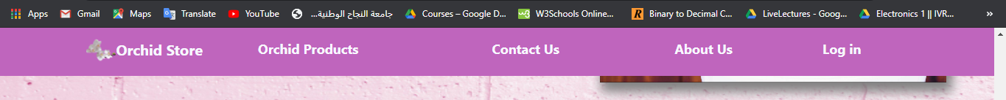The navigation bar that exists in all interfaces looks like this:
* 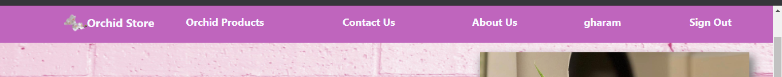The bar changes contents when you are logged in to show your name and give the option to sign out to look like this:
* The bar navigates you through the different interfaces and help you browse the site easier.

1. Home page (index page):

* 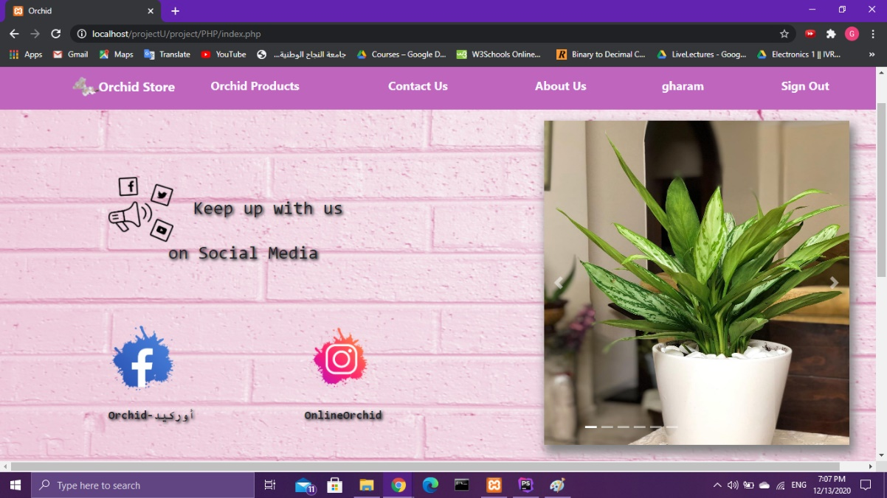The first page you see as you enter you can access it by clicking the word orchid on the nav bar and it looks like this:
* It Consists of the nav bar , a slide show with some pictures from our products , links to our social media , and the bottom part of it is the about us section .

1. About us :

* 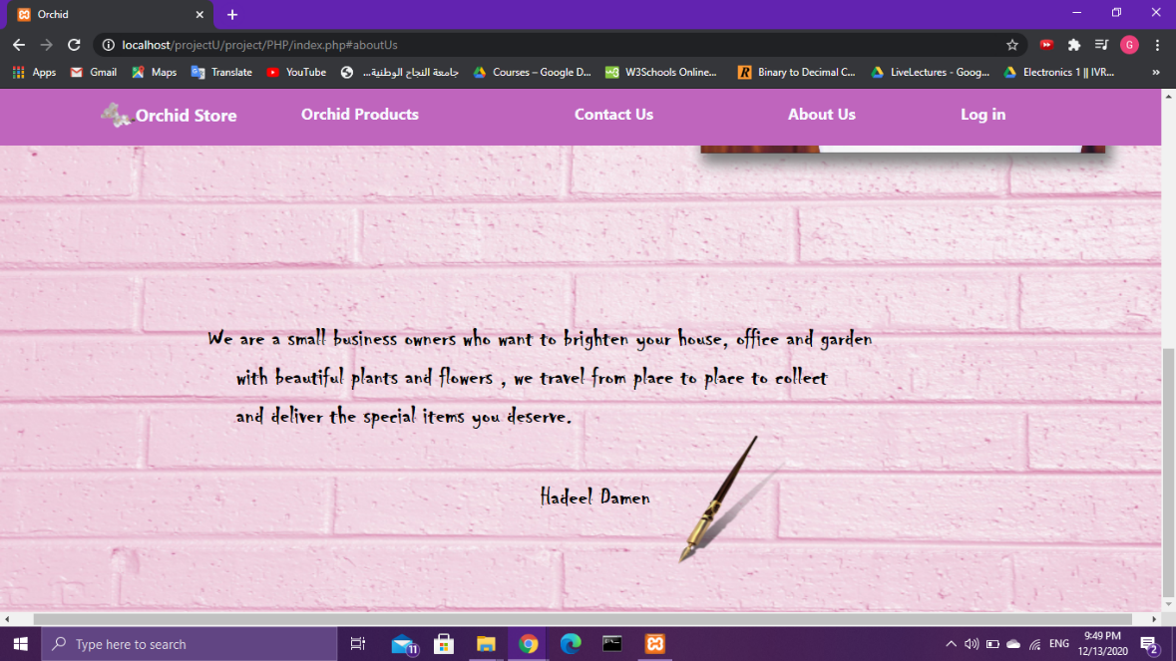This section is in the bottom of the home page , it has a bit of general information about our store , you can either scroll down the home page to reach it or you can simply click on the about us on the nav bar which takes you to this:

1. Contact us:

* 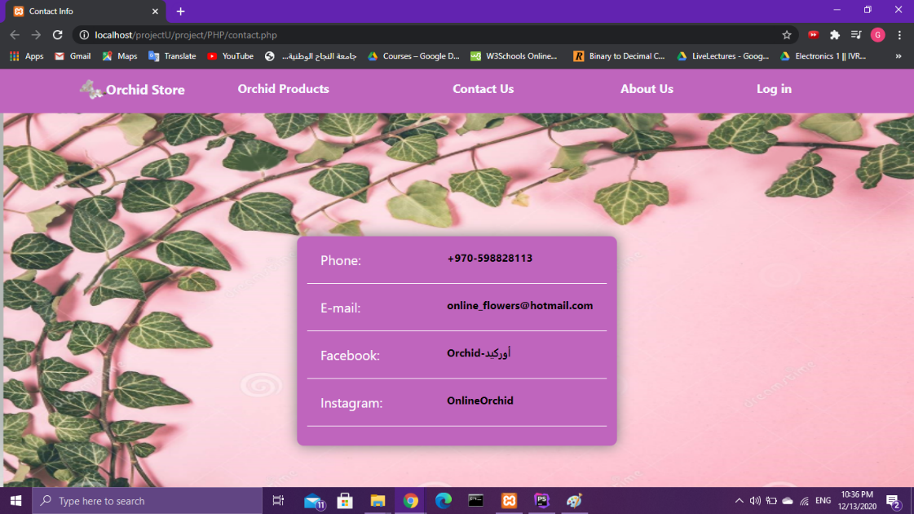This interface you can access by clicking contact us , it has all the contact information any one might need and it looks like this:

1. Log in :

* 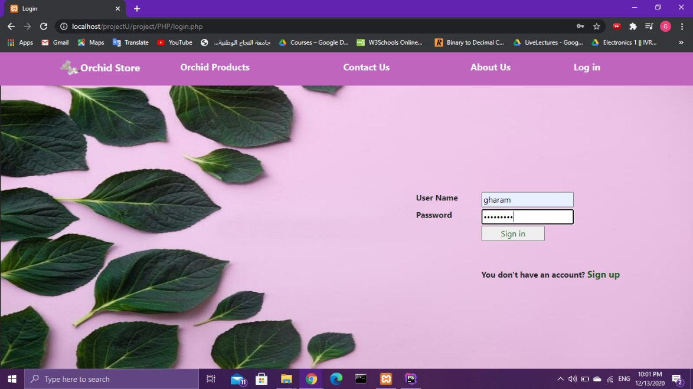This interface is accessed by clicking the log in on the nav bar and it looks like this:
* After you log in you are redirected to the interface you were in before clicking on the nav bar , and the nav bar is changed to the log in bar which displays you name .
* 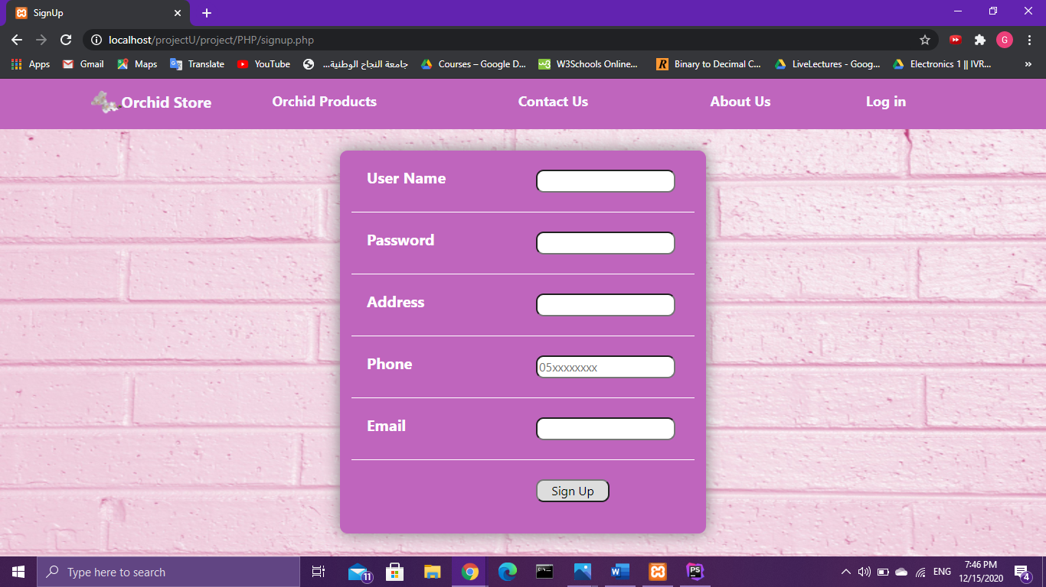This interface also has an option to sign up and create a new profile which leads you to this interface:

1. Products :

* This is the interface where all the products are displayed, and when customers click on a product it shows the specifications of that certain product from price ,name etc.
* 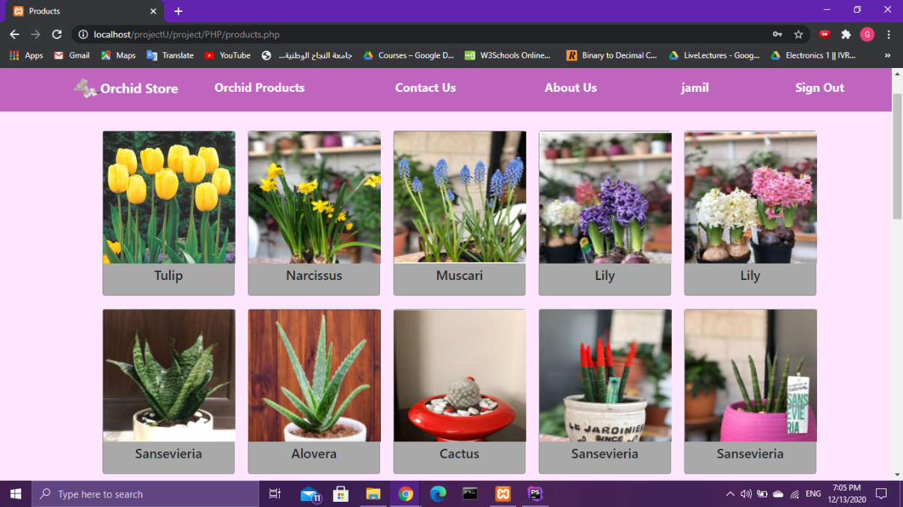This is the interface from the customer perspective:
* 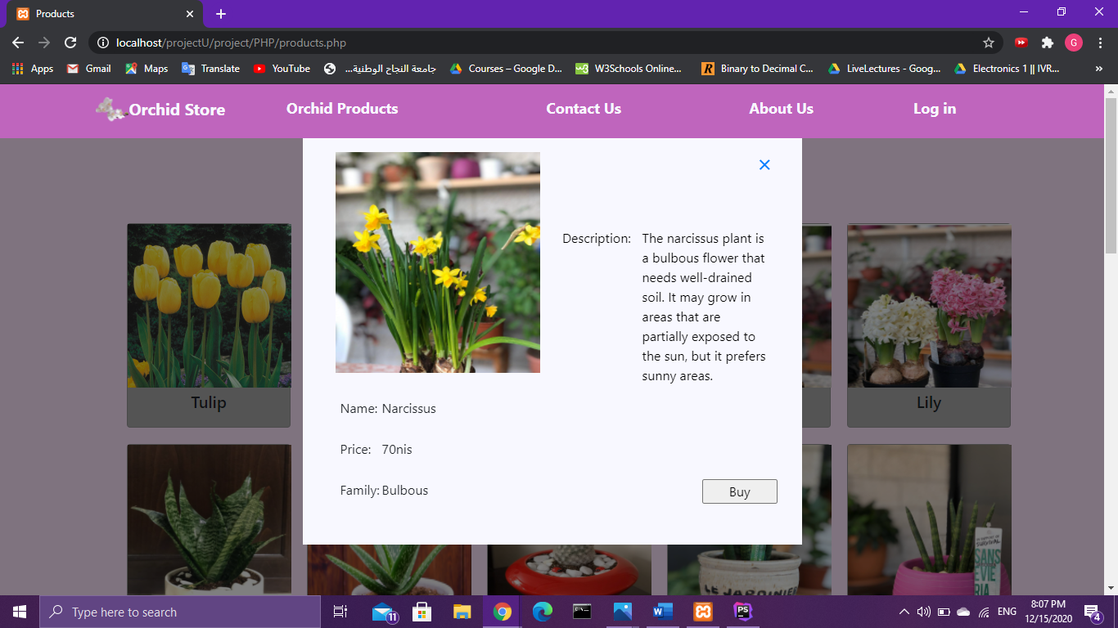And this is what’s shown when a product is chosen :
* 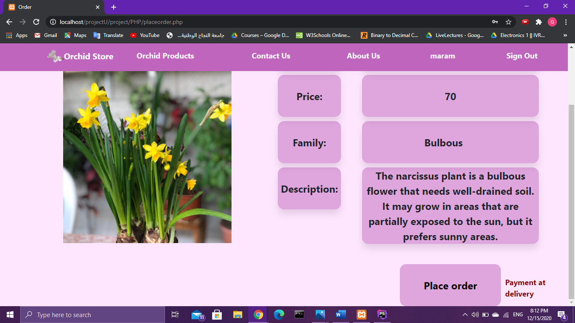Then if they want to purchase it they click on buy , if they are not logged in they are redirected to the log in interface and asked to log in and after they do they are directed to the purchase interface, if they are logged in they are immediately directed to the purchase interface that looks like this:
* The product interface is also where managers can add, remove , edit the products and view all the orders .
* 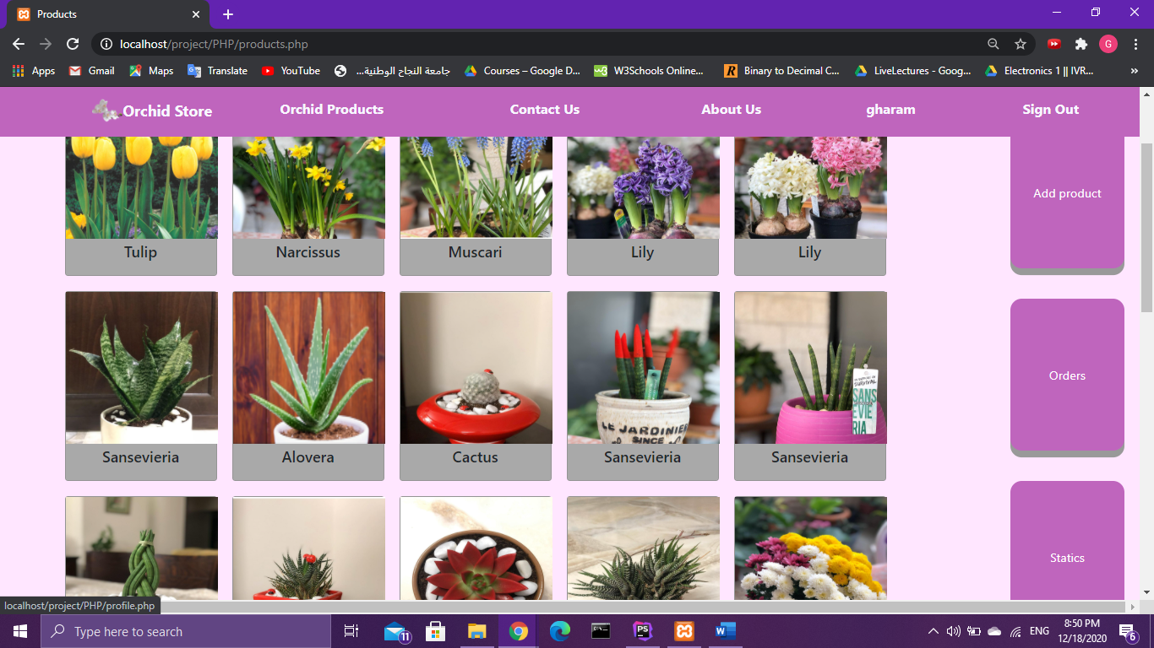This is the interface from the manager perspective:
* 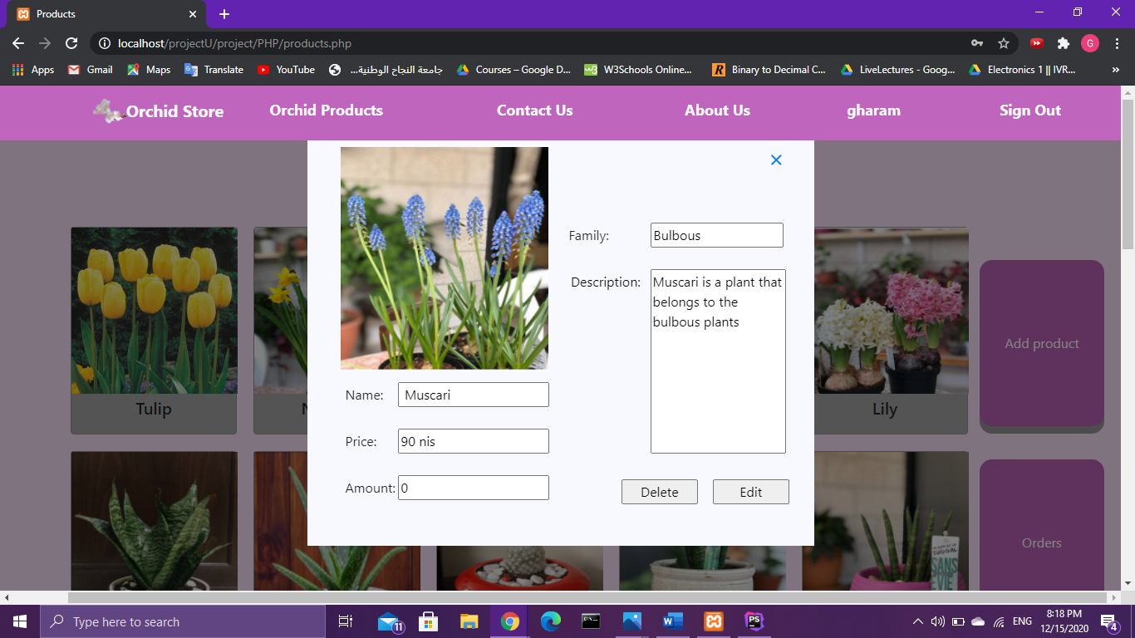They can edit and delete by clicking the targeted product :
* 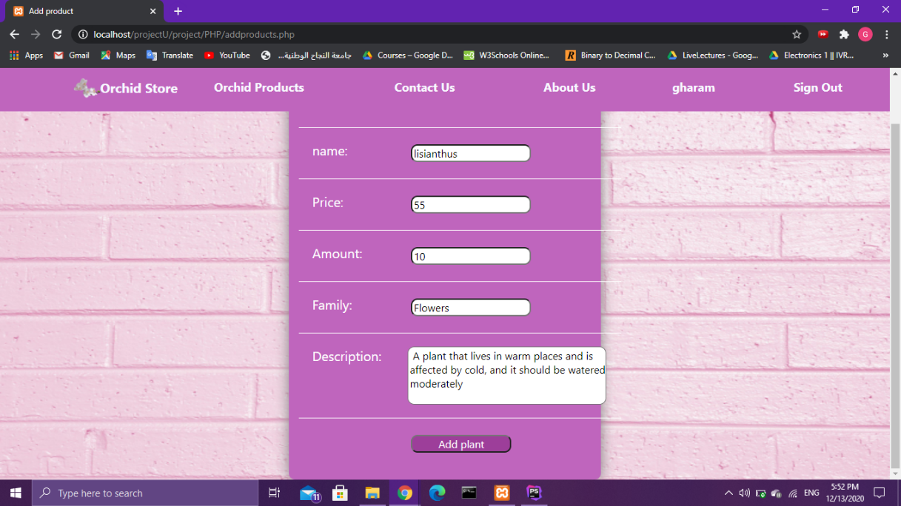And they can add products by clicking the add products button which opens this interface:
* After the product is added its added to the products interface and the database.
* 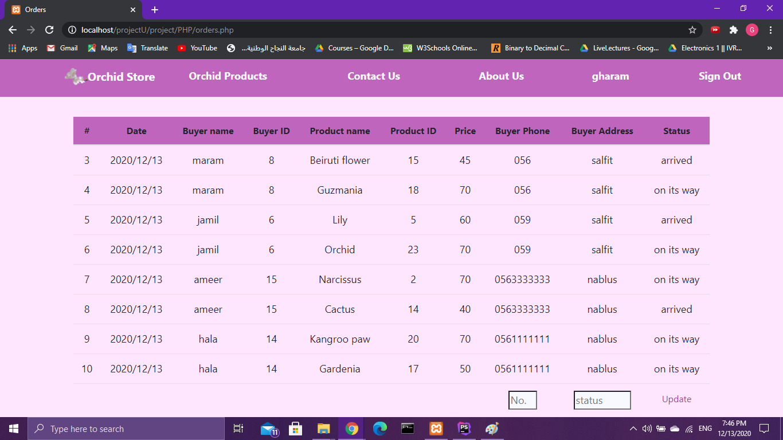Orders button opens the order interface which contains a list of all the orders stored in the database:
* There is also an option to change the status of the order in this interface ; to indicate whether it has arrived or not.
* 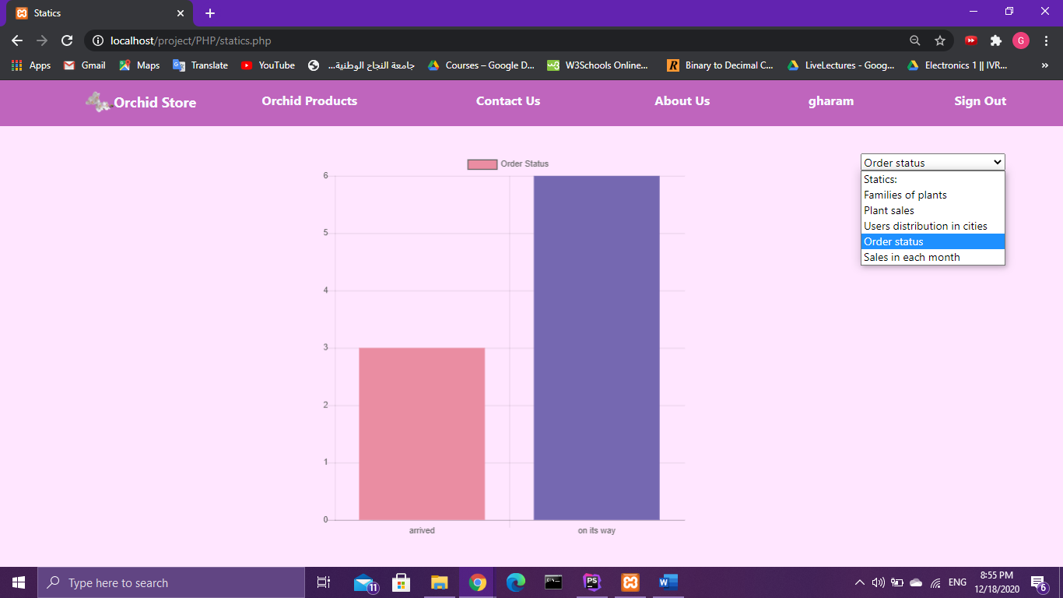Statics button has a number of statics in chart display, for the manager to keep up with the sales , products and users , the manager chooses the desired chart and it looks like this:

1. Profile :

* This interfaces is only available when you are logged in, it displays all the information you signed up with , and it gives you the option to change it :

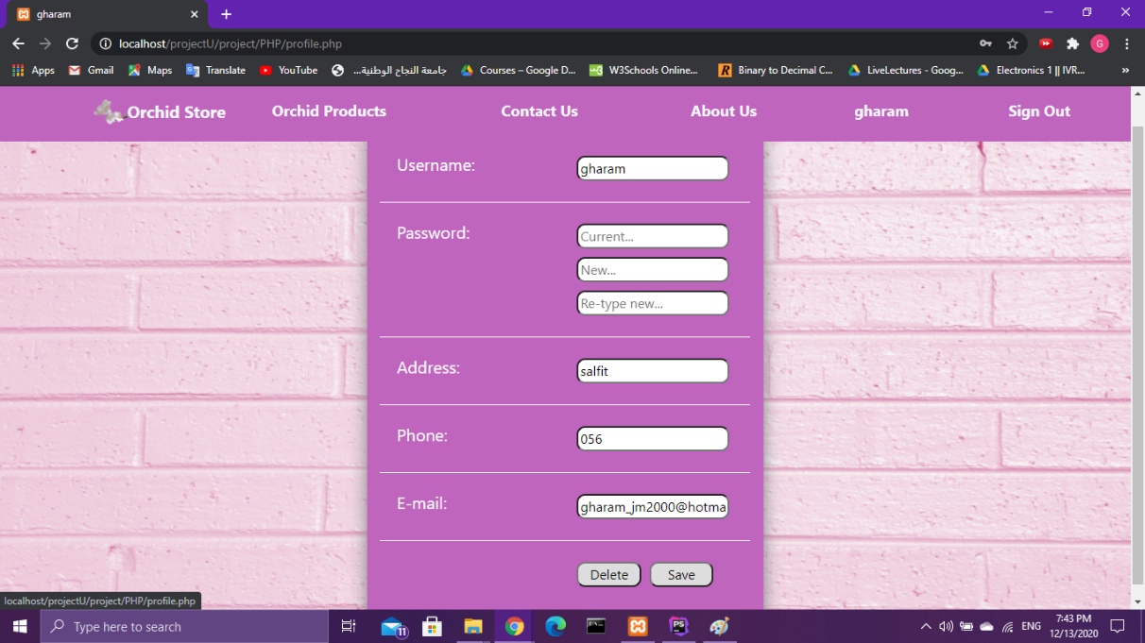

**Conclusion**

We did our best trying to create the website in this form, we hope it was good enough to save time and effort when dealing with the products and orders , our main goal was to create a website easy enough to use yet has all the necessary interfaces, for both managers and customers .

**References**

1. Course slides
2. W3Schools
3. [maxcdn.bootstrapcdn.com](http://maxcdn.bootstrapcdn.com/)
4. ajax.googleapis.com/ajax
5. Charts.js
6. Stackoverflow
7. Google
8. Youtube